|  |
| --- |
| Sukkur IBA University |
| Car Parking System |
| Instructions File |

|  |
| --- |
| 8-11-2020 |

Car Parking System

# Introduction

The Car Parking System is designed in order to computerize the manual work of storing driver and car number information. It also asks for the total duration a car would be parked and automatically calculates the parking fees. The main advantage of system is that it saves time and by reducing the workload of storing data manually and the driver data is more secure as only authorized user can access the data. The system has following features:

# Login:

Firstly, user has to enter valid username and password, in order to access the system. In case, if user types wrong username or password then the system will prompt the user to enter correct username and password until he provides correct login information.

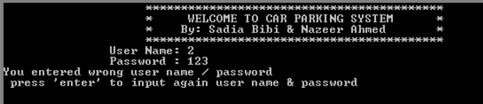

Correct login information of our system is given below:

**Username:** Nazeer&Sadia

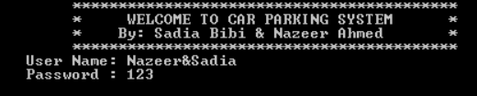**Password**: 123

# **Working of the Program:**

When user enters correct login information, he will be prompted to following three options:

1. Arrival of car
2. Display car records
3. Total number of cars arrived

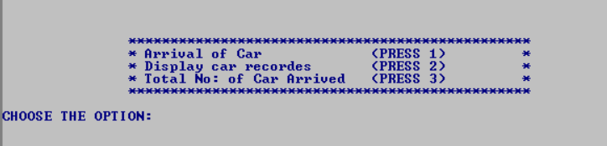

After showing these options, he/she has to select the option number for specific task. Each of the task is described below:

# Arrival of Car

Whenever a car arrives for parking, the system administrator would store the driver name, car number, total duration car would be parked information using filing. In addition to that, the system would automatically calculate the bill for parking.

For our system we charge 100 rupees per hour.

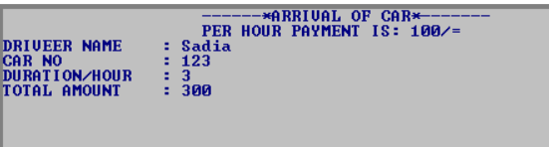

# Display Car Records

When user enters the option 2, the system would show him/her car numbers and drier names of all the cars parked.

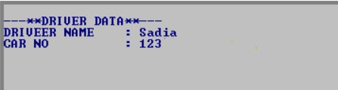

# Total Cars Arrived

When user selects option 3, the system would simply total number of cars arrived.



# ****Filing Instructions****

Please do the following to use the files for the, Car Parking System.

1. Copy files **carno** and **driverdata**
2. Open C drive in your computer
3. Open folder for emulator, namely emu8086
4. Open folder MyBuild
5. Paste the copied files into folder MyBuild

